All Array Programs:

**1.Find Numbers with Even Number of Digits**

2.Given an array nums of integers, return how many of them contain an **even number** of digits.

**Example 1:**

**Input:** nums = [12,345,2,6,7896]

**Output:** 2

**Explanation:**

12 contains 2 digits (even number of digits).

345 contains 3 digits (odd number of digits).

2 contains 1 digit (odd number of digits).

6 contains 1 digit (odd number of digits).

7896 contains 4 digits (even number of digits).

Therefore only 12 and 7896 contain an even number of digits.

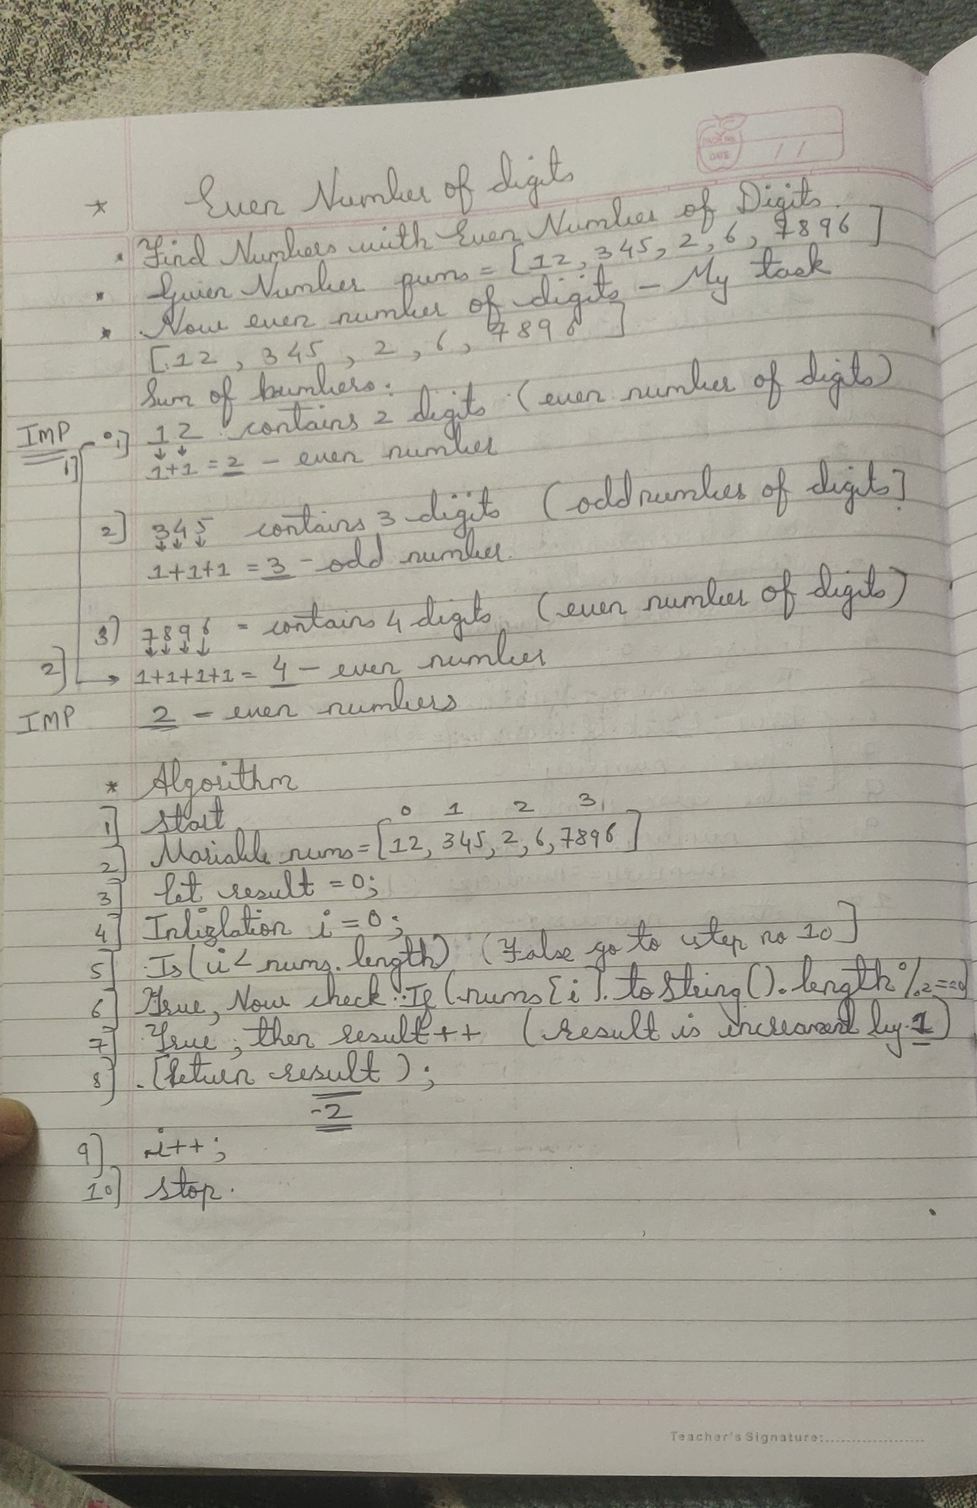

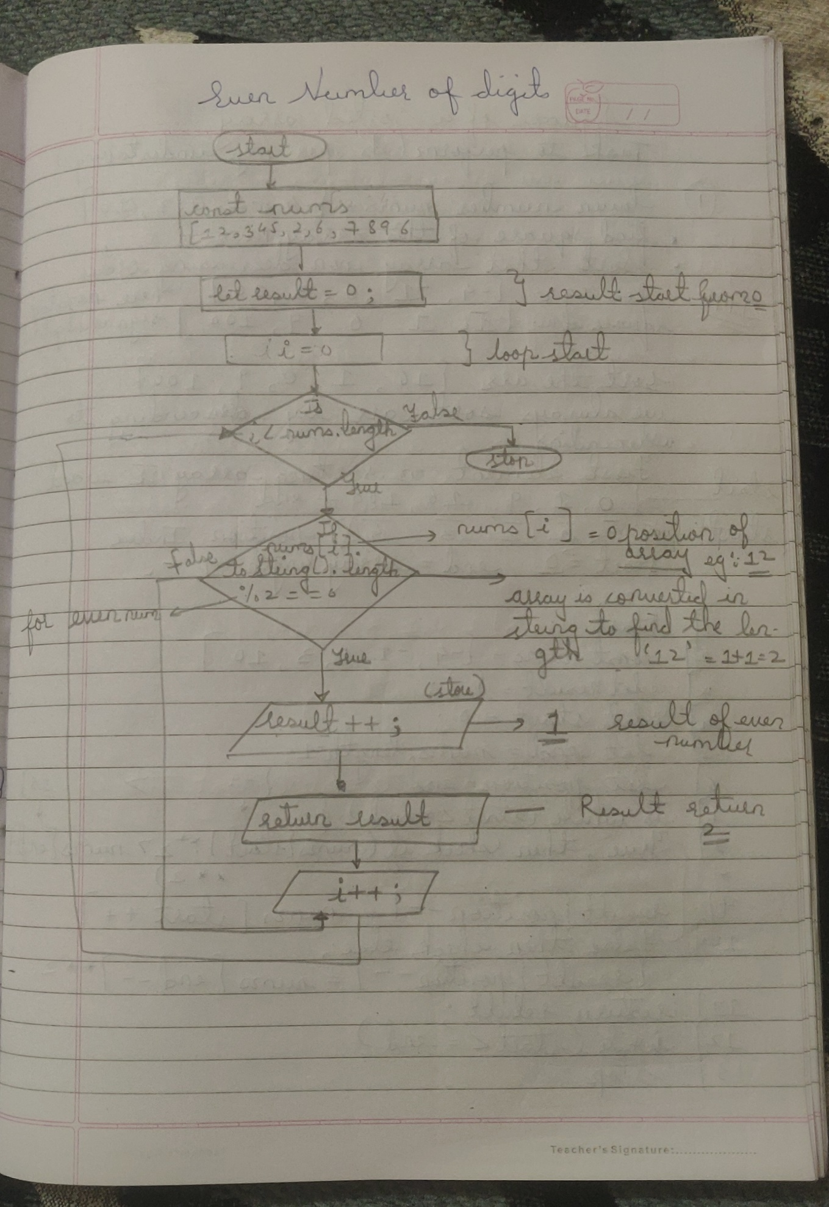

Solution:

function findNumbers(nums) {

let number = 0;

for (let i = 0; i < nums.length; i++) {

if (nums[i].toString().length % 2 == 0) {

number++;

}

}

return number;

}

Output:

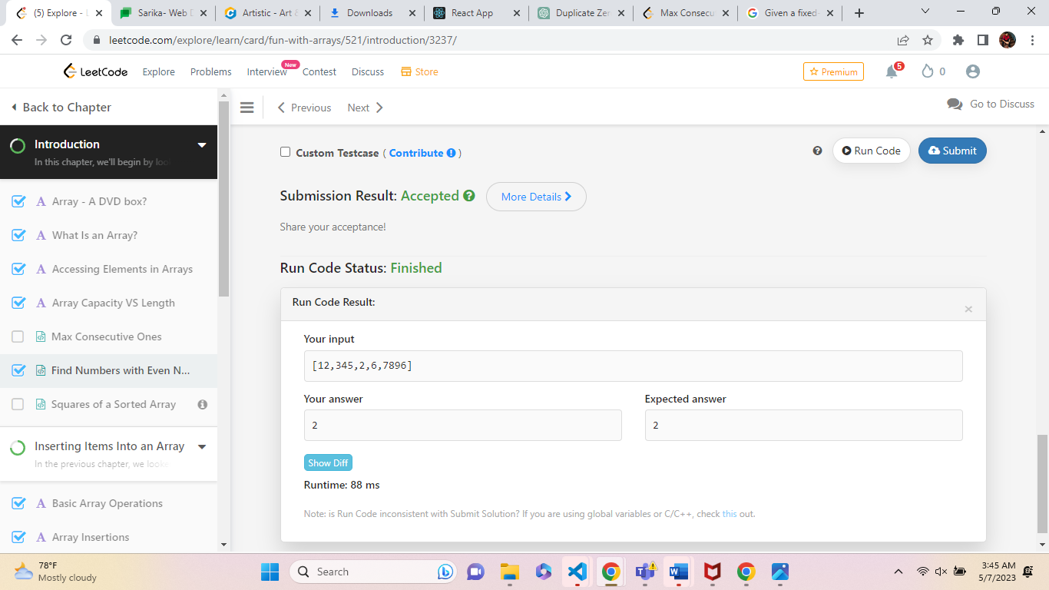

**Example 2:**

Given an array nums of integers, return how many of them contain an **even number** of digits.

**Example 2:**

**Input:** nums = [555,901,482,1771]

**Output:** 1

**Explanation:**

Only 1771 contains an even number of digits.

Solution:

function findNumbers(nums){

let number = 0;

for (let i = 0; i < nums.length; i++) {

if (nums[i].toString().length % 2 == 0) {

number++;

}

}

return number;

}

Output:

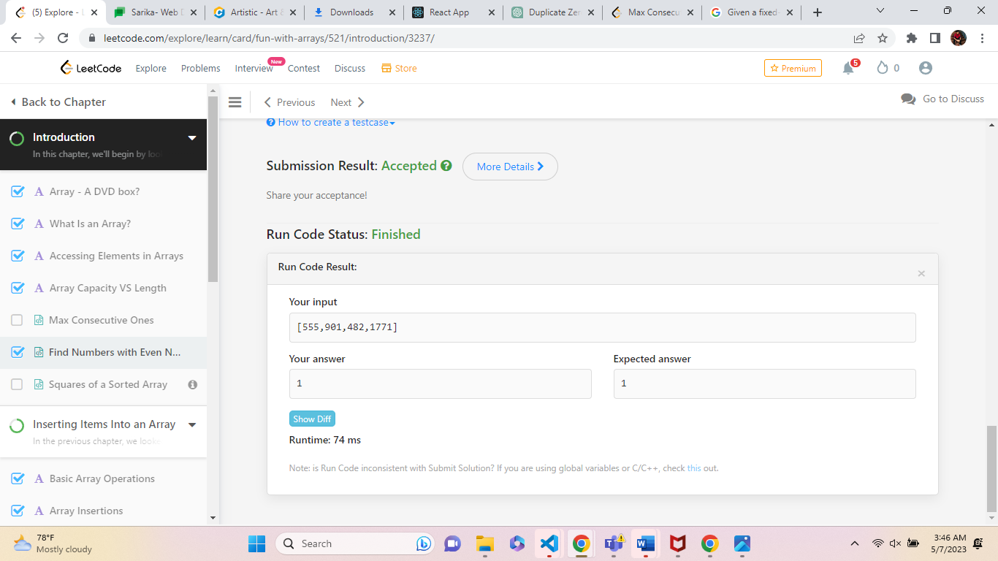

**2.Squares of a Sorted Array**

Given an integer array nums sorted in **non-decreasing** order, return an array of ***the squares of each number*** sorted in non-decreasing order.

**Example 1:**

**Input:** nums = [-4,-1,0,3,10]

**Output:** [0,1,9,16,100]

**Explanation:** After squaring, the array becomes [16,1,0,9,100].

After sorting, it becomes [0,1,9,16,100].

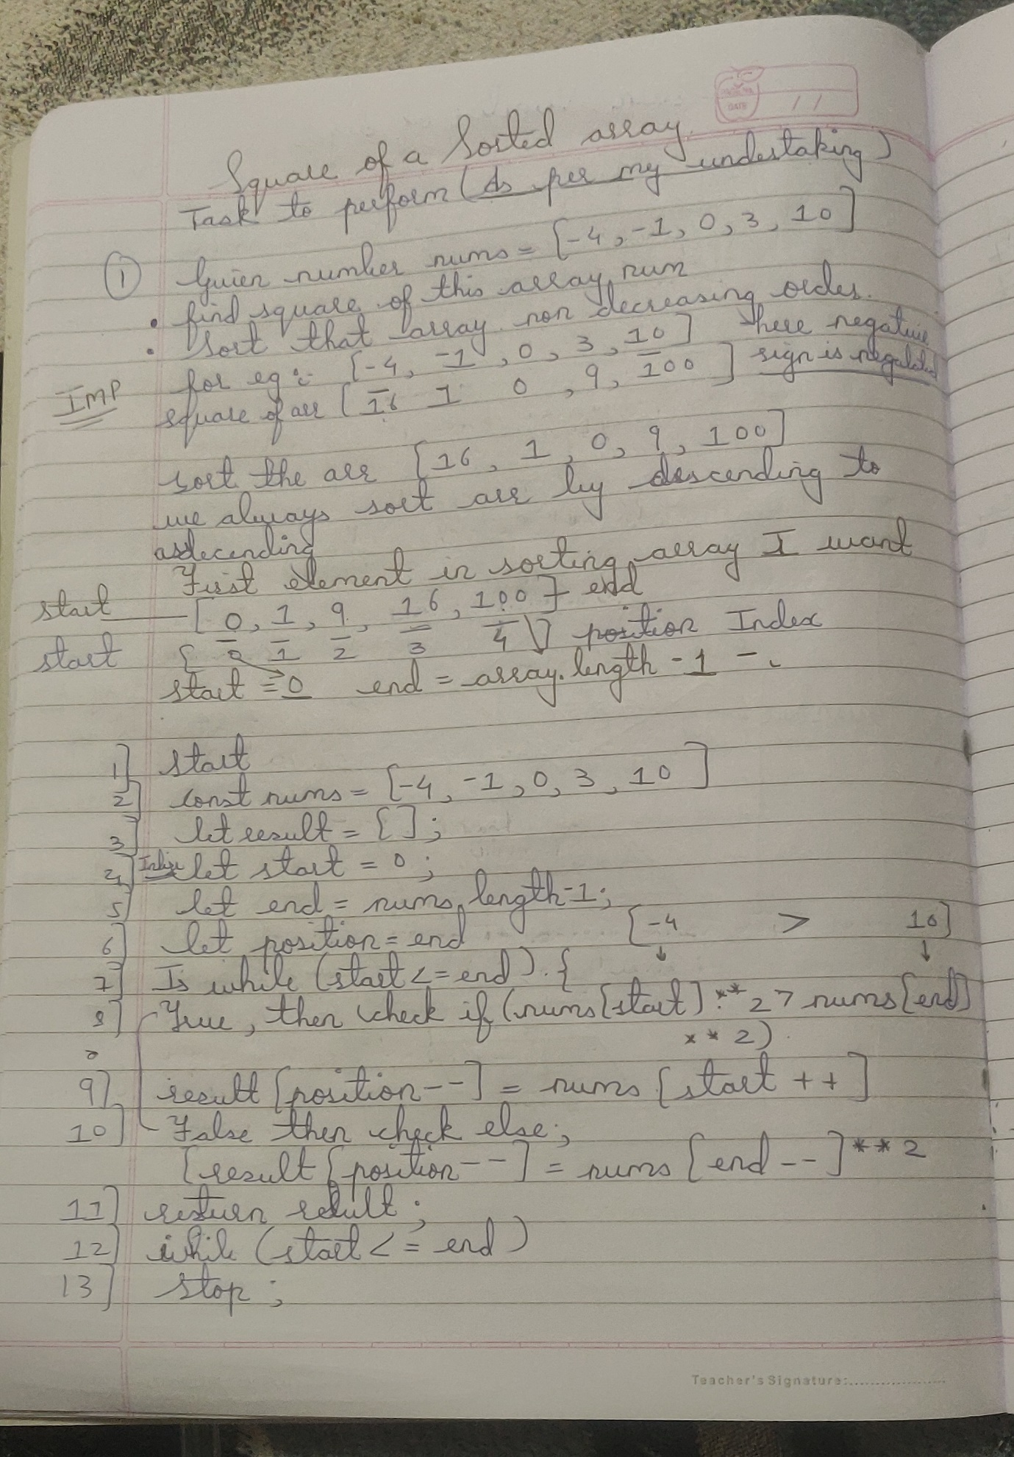

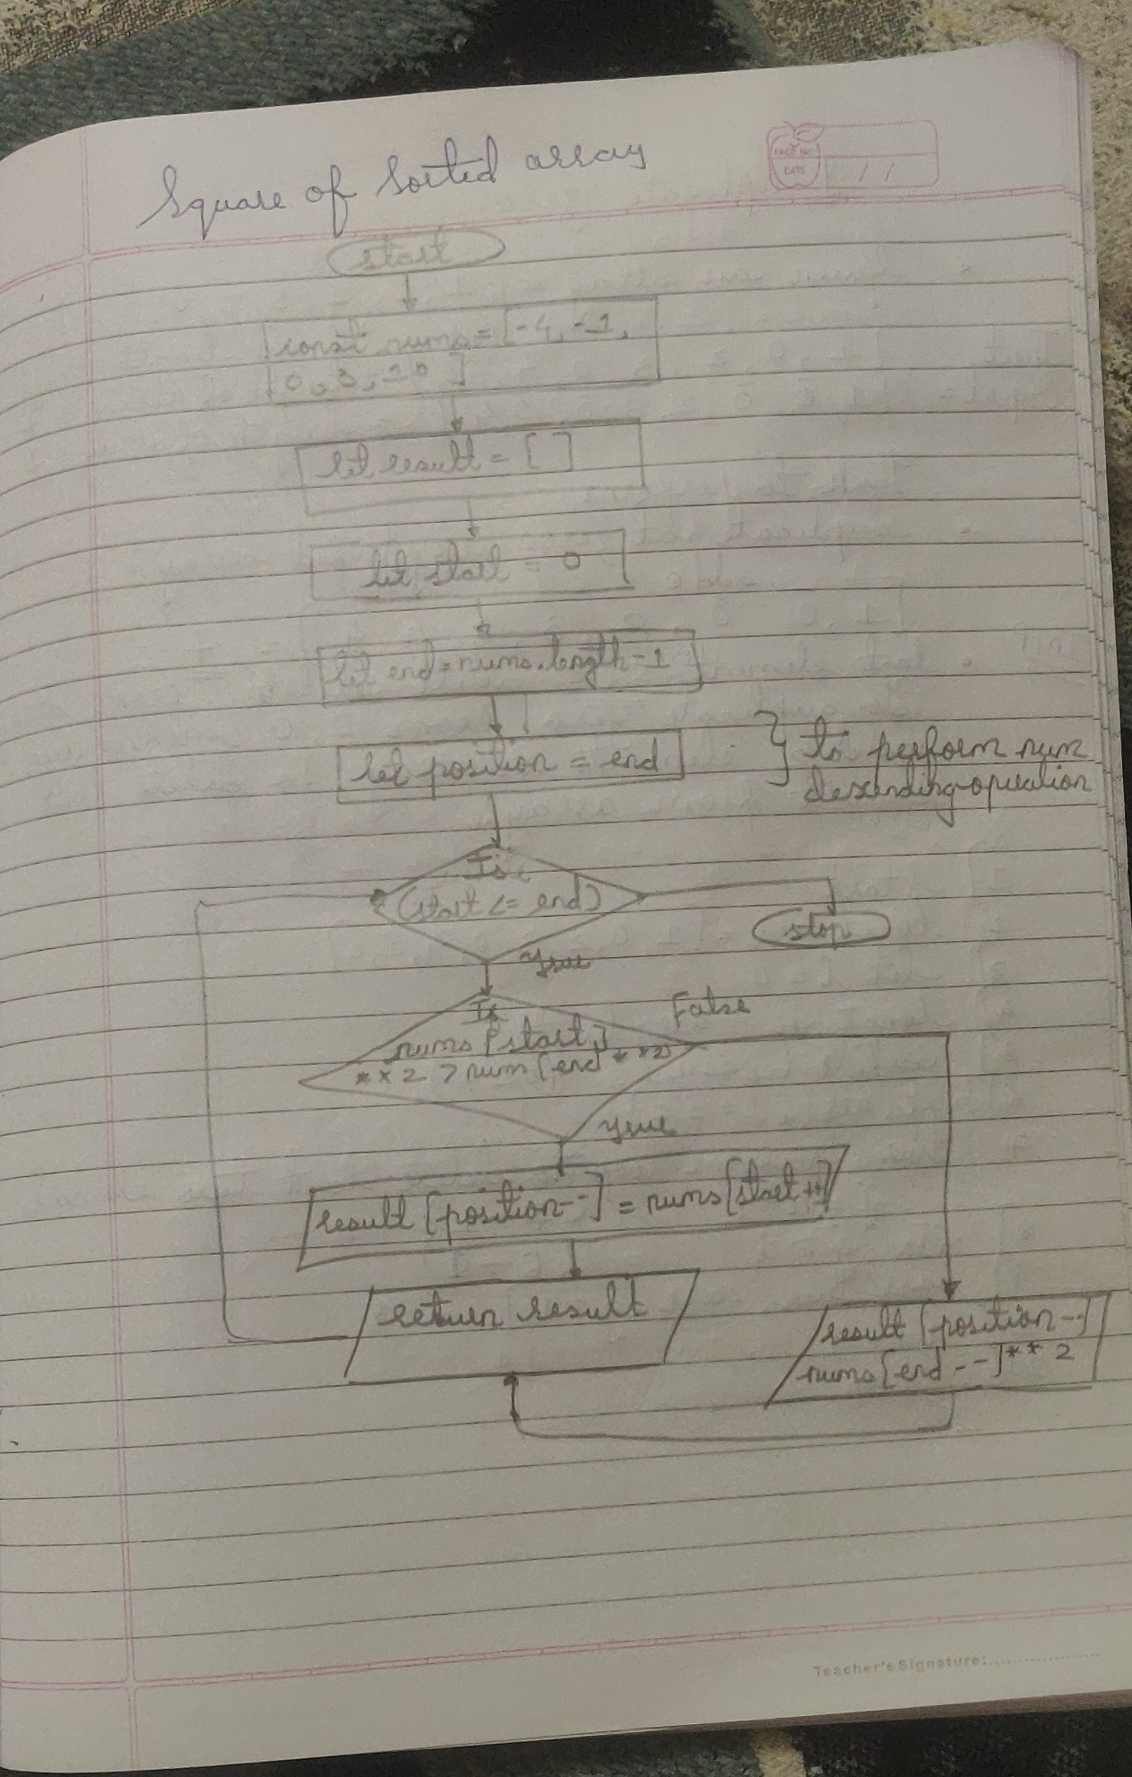

Solution:

function sortedSquares (nums) {

//const nums = [-4,-1,0,3,10]//

let result = []

let start = 0

let end = nums.length;

let position = end

while (start <= end) {

if (nums[start] ** 2 > nums[end] ** 2) {

result[position--] = nums[start++]

} else

{

result[position--] = nums[end--] ** 2

}

}

return result;

};

Output:

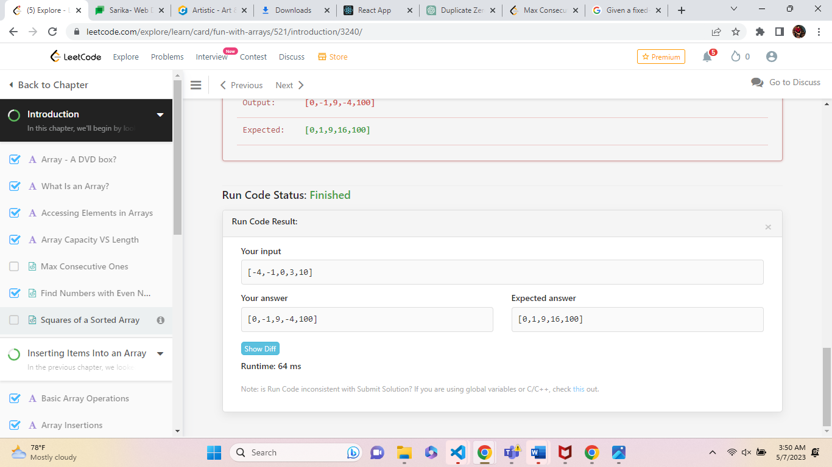

**3.Max Consecutive Ones**

1.Given a binary array nums, return *the maximum number of consecutive*1*'s in the array*.

**Example 1:**

**Input:** nums = [1,1,0,1,1,1]

**Output:** 3

**Explanation:** The first two digits or the last three digits are consecutive 1s. The maximum number of consecutive 1s is 3.

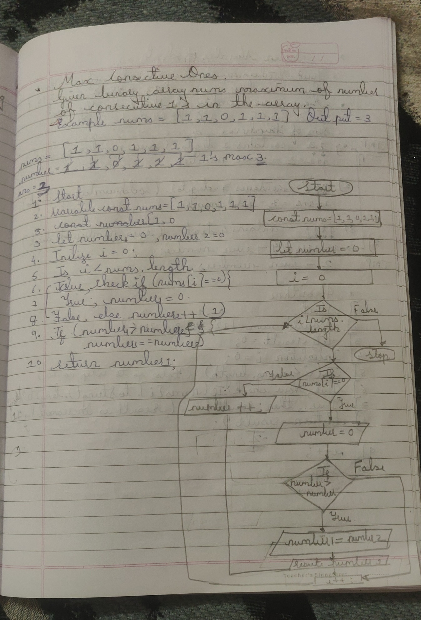

Solution:

var findMaxConsecutiveOnes = function() {

const nums = [1,1,0,1,1,1]

let number1=0;

let number2= 0;

for (let i = 0; i<nums.length; i++) {

if (nums[i] == 0) {

number1 =0;

}

else

{

Number2++;

}

if(number1>number2){

(number2==number1)

}

}

return number;

};

Solution:

var findMaxConsecutiveOnes = function(nums){

let maxFirst =0;

let maxSecond =0;

for (let i = 0; i<nums.length; i++) {

if (nums[i] === 1) {

maxFirst++;

} else {

maxSecond =0;

}

if(maxFirst > maxSecond){

maxSecond = maxFirst;

}

}

return maxFirst;

}

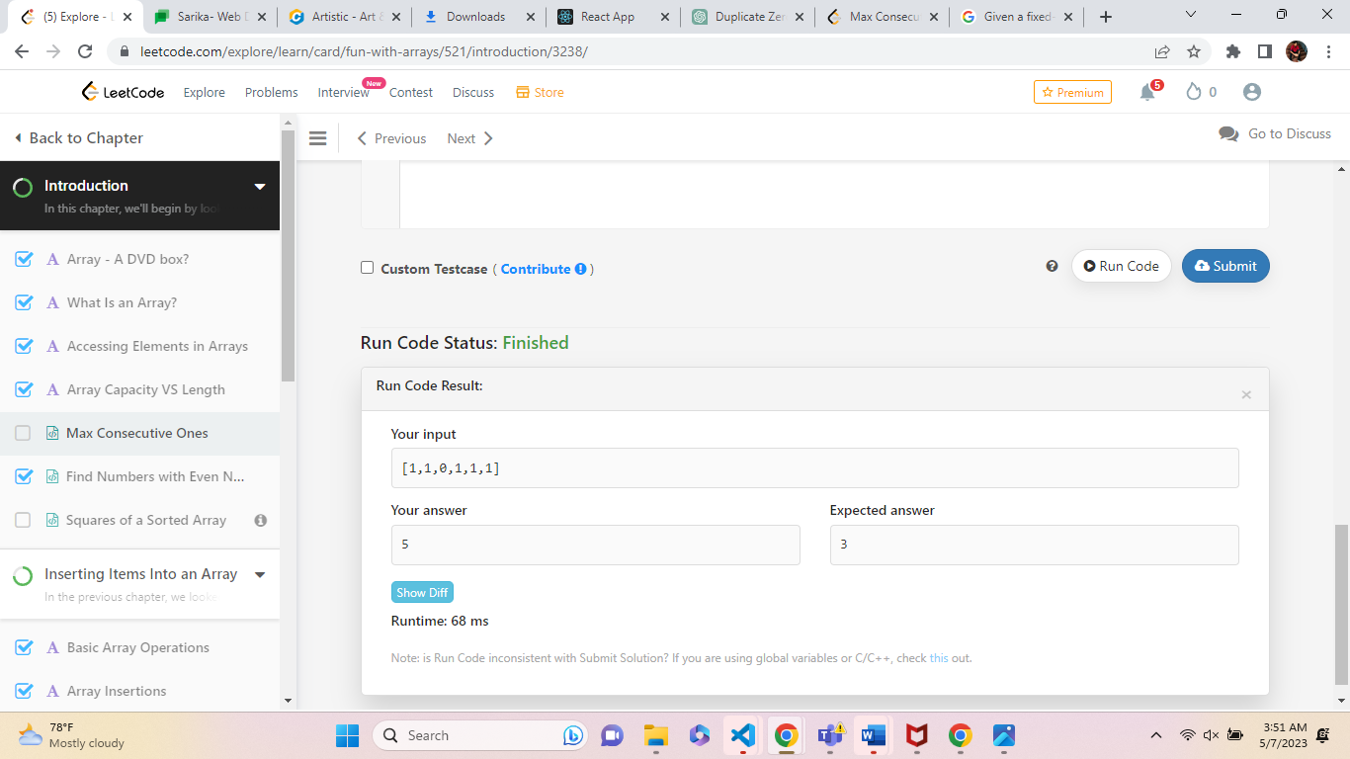

**4.Duplicate Zeros**

Given a fixed-length integer array arr, duplicate each occurrence of zero, shifting the remaining elements to the right.

**Note** that elements beyond the length of the original array are not written. Do the above modifications to the input array in place and do not return anything.

**Example 1:**

**Input:** arr = [1,0,2,3,0,4,5,0]

**Output:** [1,0,0,2,3,0,0,4]

**Explanation:** After calling your function, the input array is modified to: [1,0,0,2,3,0,0,4]

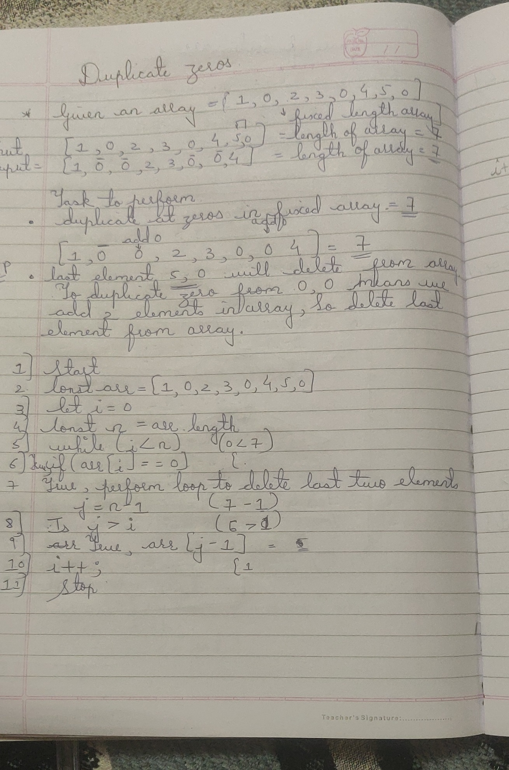

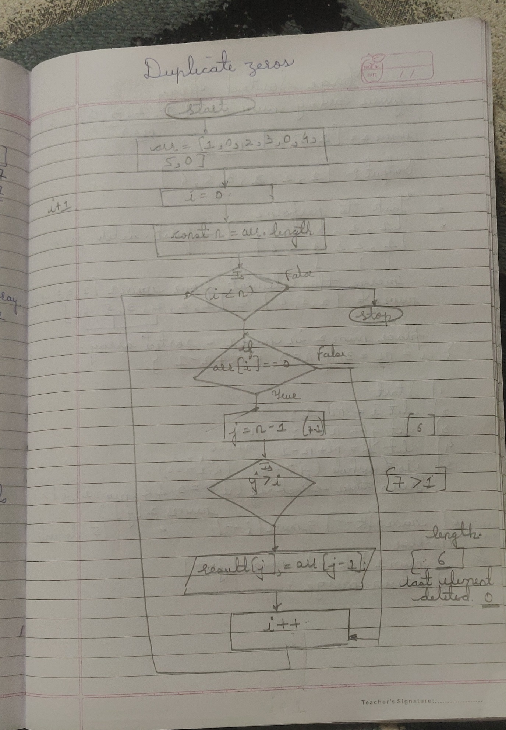

Solution:

function duplicateZeros() {

const arr = [1,0,2,3,0,4,5,0]

let i = 0;

const n = arr.length; //2//

while (i < n) { // 0 <2//

if (arr[i] == 0) { //arr[1]==0

for (let j = n - 1; j > i; j--) { // n=1 =2-1 , j--//

arr[j] = arr[j - 1];

}

i++;

}

i++;

}

}

Solution:

function duplicateZeros(arr){

for (let i = 0; i < arr.length; i++) {

if (arr[i] == 0) {

for (let j = arr.length-1; j > i; j--) {

arr[j] = arr[j - 1];

}

arr[i+0] = 0;

i++;

}

}

}

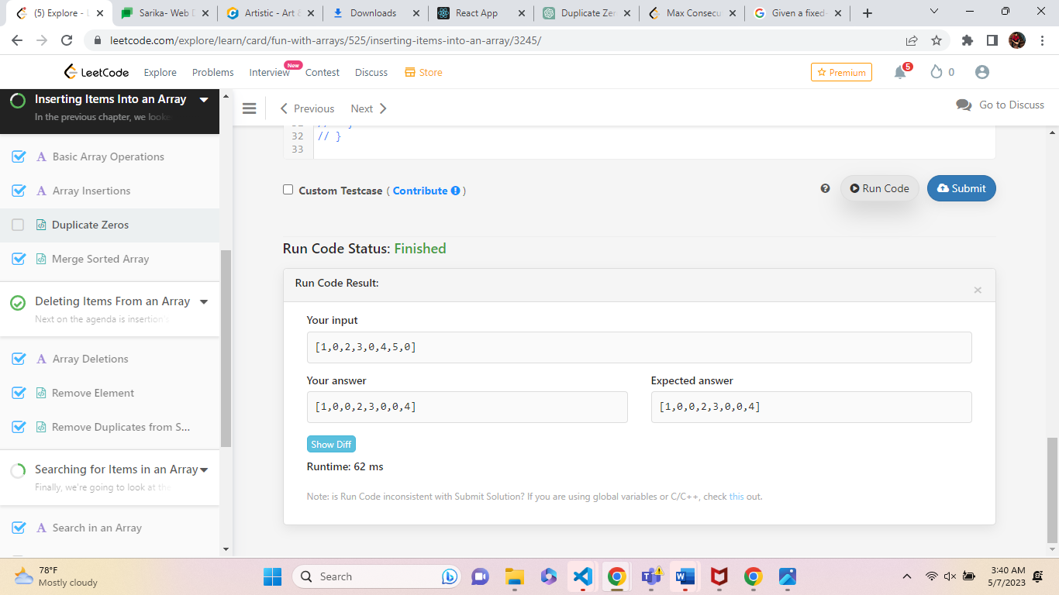

**Example 2:**

**Input:** arr = [1,2,3]

**Output:** [1,2,3]

**Explanation:** After calling your function, the input array is modified to: [1,2,3]

Solution:

function duplicateZeros(arr) {

let i = 0;

const n = arr.length; //2//

while (i < n) { // 0 <2//

if (arr[i] == 0) { //arr[1]==0

for (let j = n - 1; j > i; j--) {

arr[j] = arr[j - 1];

}

}

i++;

}

}

**Output:**

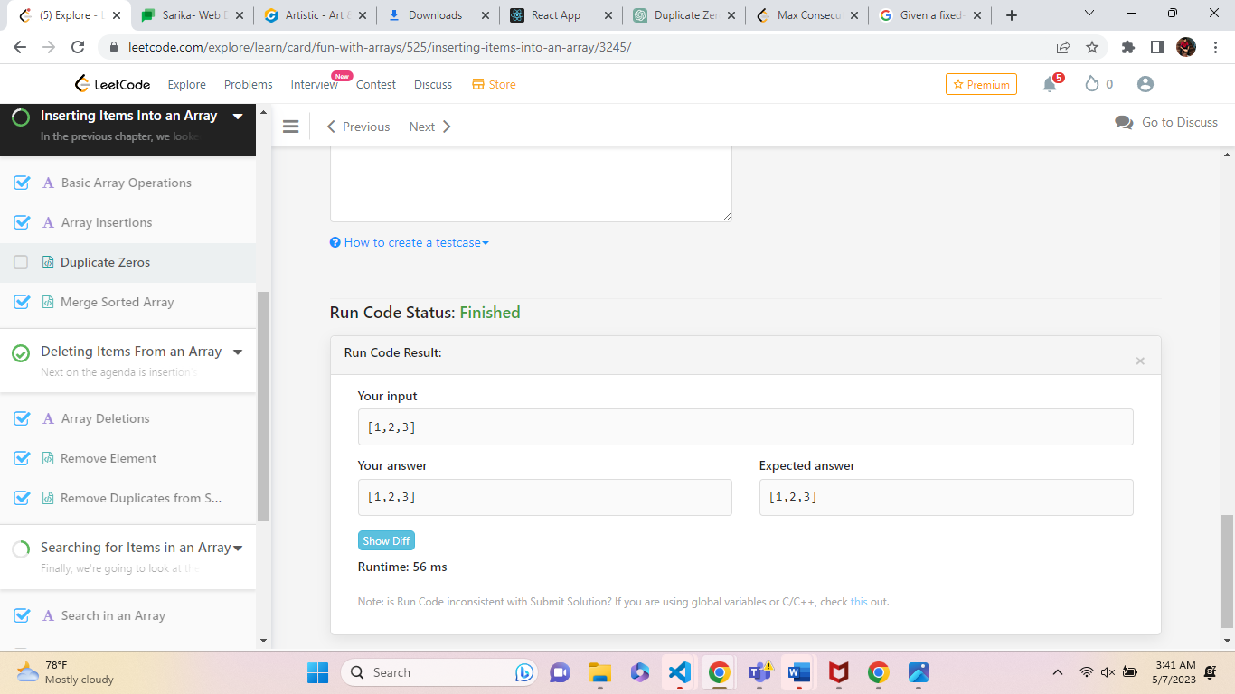

**5.Merge Sorted Array**

You are given two integer arrays nums1 and nums2, sorted in **non-decreasing order**, and two integers m and n, representing the number of elements in nums1 and nums2 respectively.

**Merge** nums1 and nums2 into a single array sorted in **non-decreasing order**.

The final sorted array should not be returned by the function, but instead be stored inside the array nums1. To accommodate this, nums1 has a length of m + n, where the first m elements denote the elements that should be merged, and the last n elements are set to 0 and should be ignored. nums2 has a length of n.

**Example 1:**

**Input:** nums1 = [1,2,3,0,0,0], m = 3, nums2 = [2,5,6], n = 3

**Output:** [1,2,2,3,5,6]

**Explanation:** The arrays we are merging are [1,2,3] and [2,5,6].

The result of the merge is [1,2,2,3,5,6] with the underlined elements coming from nums1.

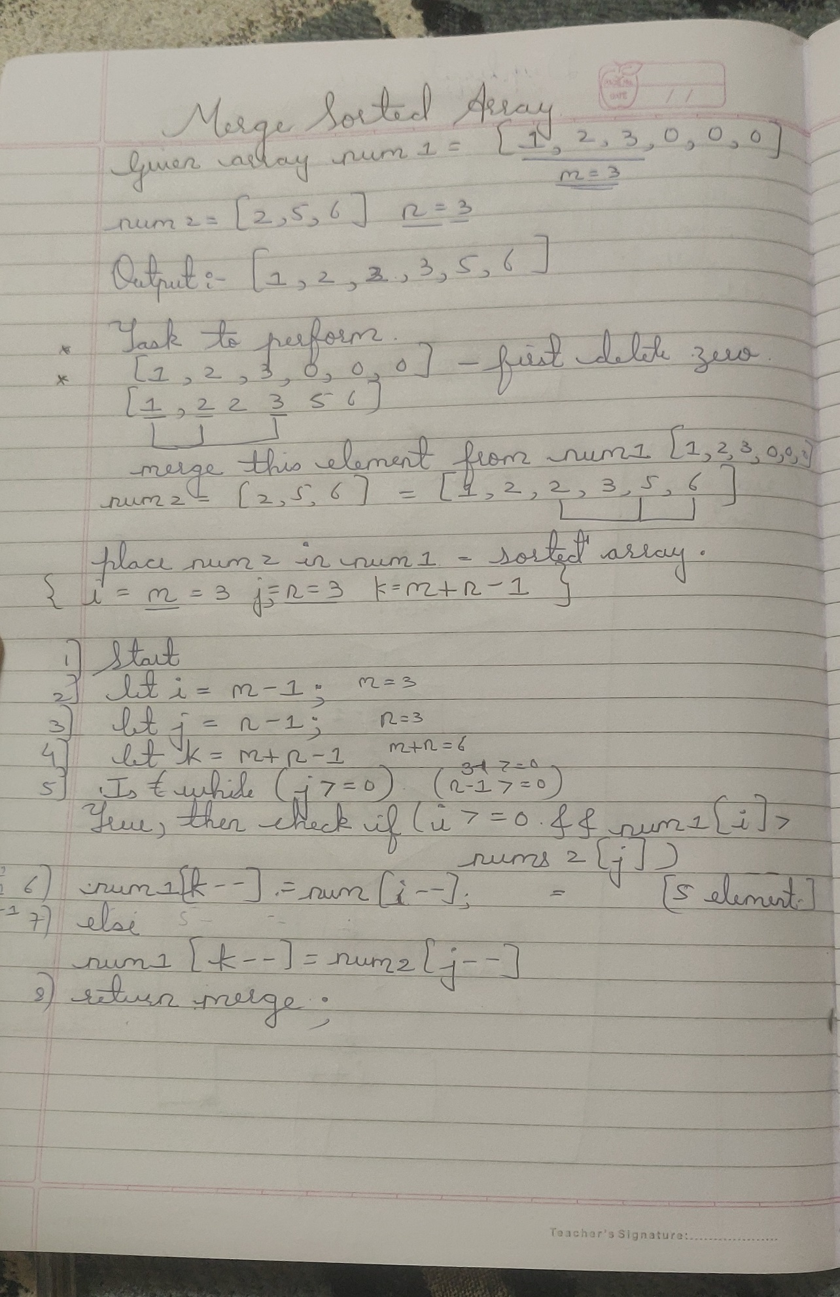

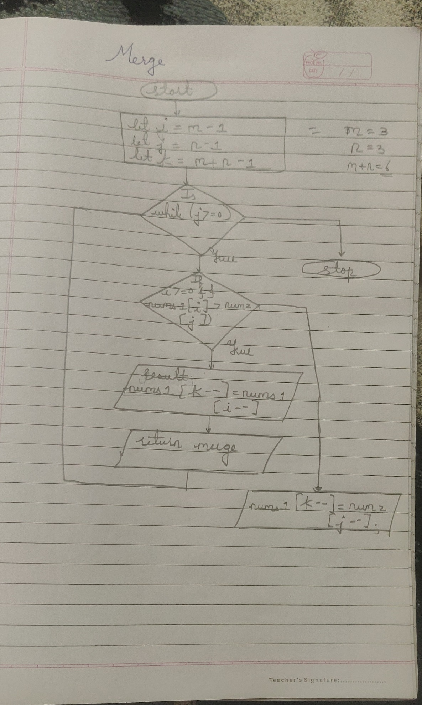

Solution:

function merge(nums1, m, nums2, n) {

let i = m - 1;

let j = n - 1;

let k = m + n - 1;

while (j >= 0) {

if (i >= 0 && nums1[i] > nums2[j]) {

nums1[k--] = nums1[i--];

} else {

nums1[k--] = nums2[j--];

}

}

}

return merge };

Output:

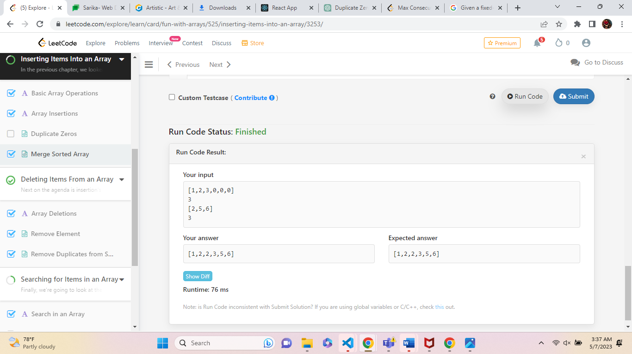

**6.Remove Element**

Given an integer array nums and an integer val, remove all occurrences of val in nums [**in-place**](https://en.wikipedia.org/wiki/In-place_algorithm). The order of the elements may be changed. Then return *the number of elements in*nums*which are not equal to*val.

Consider the number of elements in nums which are not equal to val be k, to get accepted, you need to do the following things:

* Change the array nums such that the first k elements of nums contain the elements which are not equal to val. The remaining elements of nums are not important as well as the size of nums.
* Return k.
* **Example 1:**
* **Input:** nums = [3,2,2,3], val = 3
* **Output:** 2, nums = [2,2,_,_]
* **Explanation:** Your function should return k = 2, with the first two elements of nums being 2.
* It does not matter what you leave beyond the returned k (hence they are underscores).

Solution:

function removeElement(nums, val) {

let k = 0;

for (let i = 0; i < nums.length; i++) {

if (nums[i] !== val) {

nums[k] = nums[i];

k++;

}

}

return k;

}

Output:

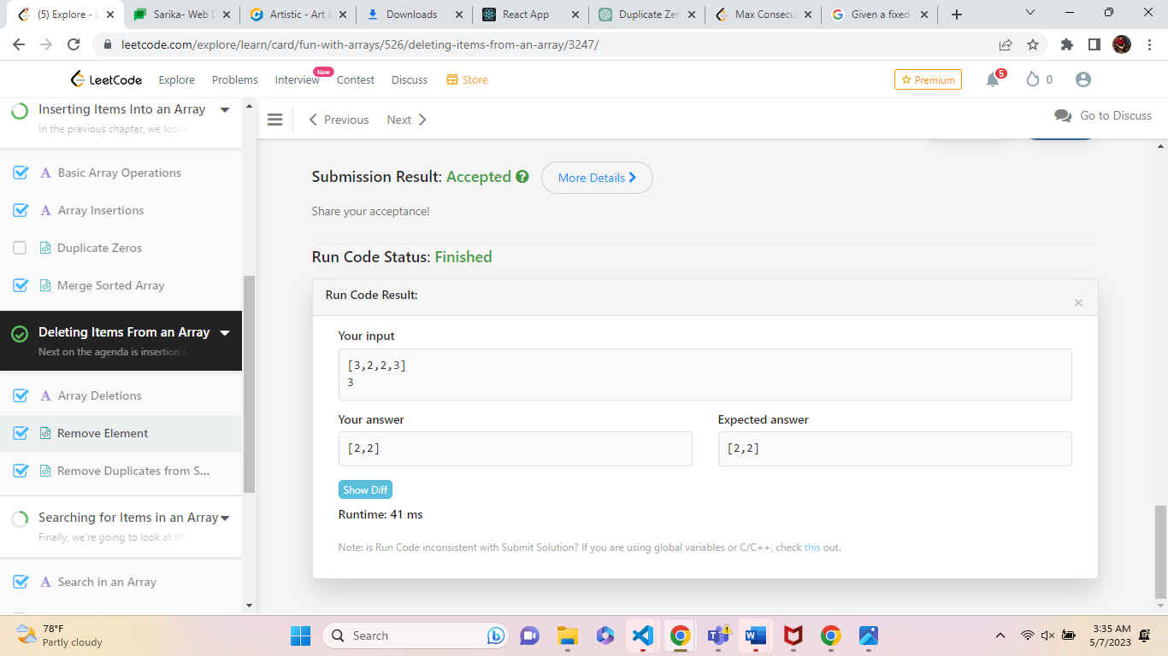

**7.Remove Duplicates from Sorted Array**

Given an integer array nums sorted in **non-decreasing order**, remove the duplicates [**in-place**](https://en.wikipedia.org/wiki/In-place_algorithm) such that each unique element appears only **once**. The **relative order** of the elements should be kept the **same**. Then return *the number of unique elements in*nums.

Consider the number of unique elements of nums to be k, to get accepted, you need to do the following things:

* Change the array nums such that the first k elements of nums contain the unique elements in the order they were present in nums initially. The remaining elements of nums are not important as well as the size of nums.
* Return k.
* **Example 1:**
* **Input:** nums = [1,1,2]
* **Output:** 2, nums = [1,2,_]
* **Explanation:** Your function should return k = 2, with the first two elements of nums being 1 and 2 respectively.
* It does not matter what you leave beyond the returned k (hence they are underscores).

**Solution:**

var removeDuplicates = function(nums) {

let k = 0;

for (let i = 0; i < nums.length; i++) {

if (i == 0 || nums[i] != nums[i - 1]) {

nums[k] = nums[i];

k++;

}

}

return k;

};

Output:

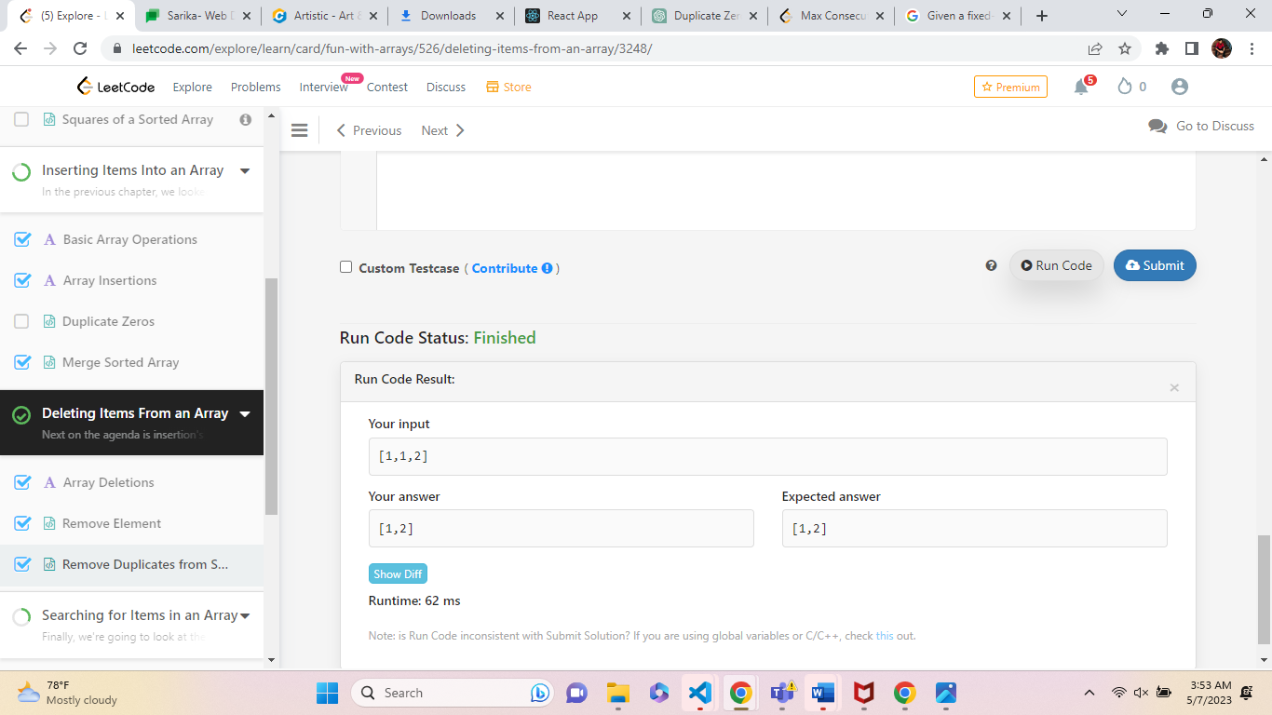

**Example 2:**

**Input:** nums = [0,0,1,1,1,2,2,3,3,4]

**Output:** 5, nums = [0,1,2,3,4,_,_,_,_,_]

**Explanation:** Your function should return k = 5, with the first five elements of nums being 0, 1, 2, 3, and 4 respectively.

It does not matter what you leave beyond the returned k (hence they are underscores).

Solution:

var removeDuplicates = function(nums) {

let k = 0;

for (let i = 0; i < nums.length; i++) {

if (i == 0 || nums[i] != nums[i - 1]) {

nums[k] = nums[i];

k++;

}

}

return k;

};

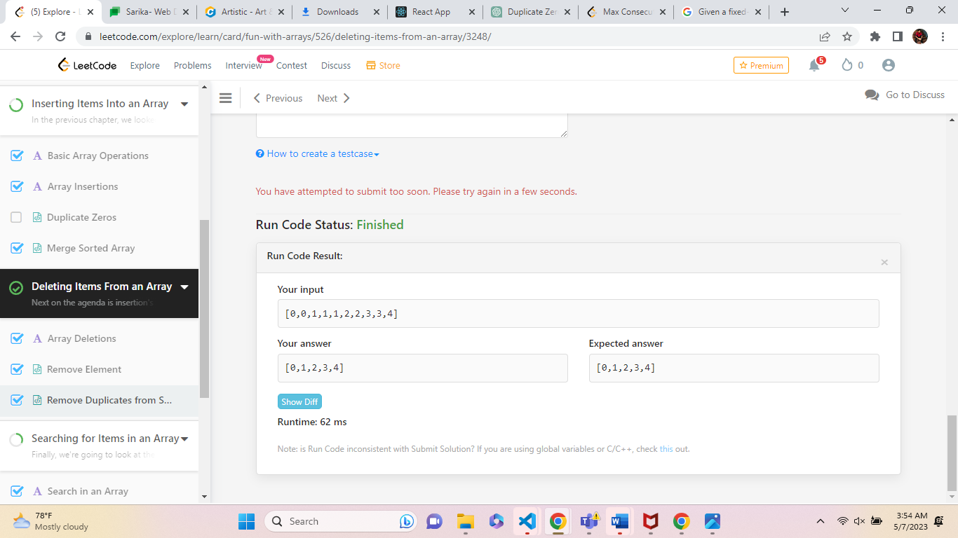

**8.Check If N and Its Double Exist**

Given an array arr of integers, check if there exist two indices i and j such that :

* i != j
* 0 <= i, j < arr.length
* arr[i] == 2 * arr[j]

**Example 1:**

**Input:** arr = [10,2,5,3]

**Output:** true

**Explanation:** For i = 0 and j = 2, arr[i] == 10 == 2 * 5 == 2 * arr[j]

Solution:

var checkIfExist= function(arr){

let result;

for (let i = 0; i < arr.length; i++) {

for (let j = 2; j < arr.length; j++) {

if (arr[i] == 10 == 2 * 5 == 2 * arr[j]) {

return (false);

}

}

return (true)

}

}

Output:

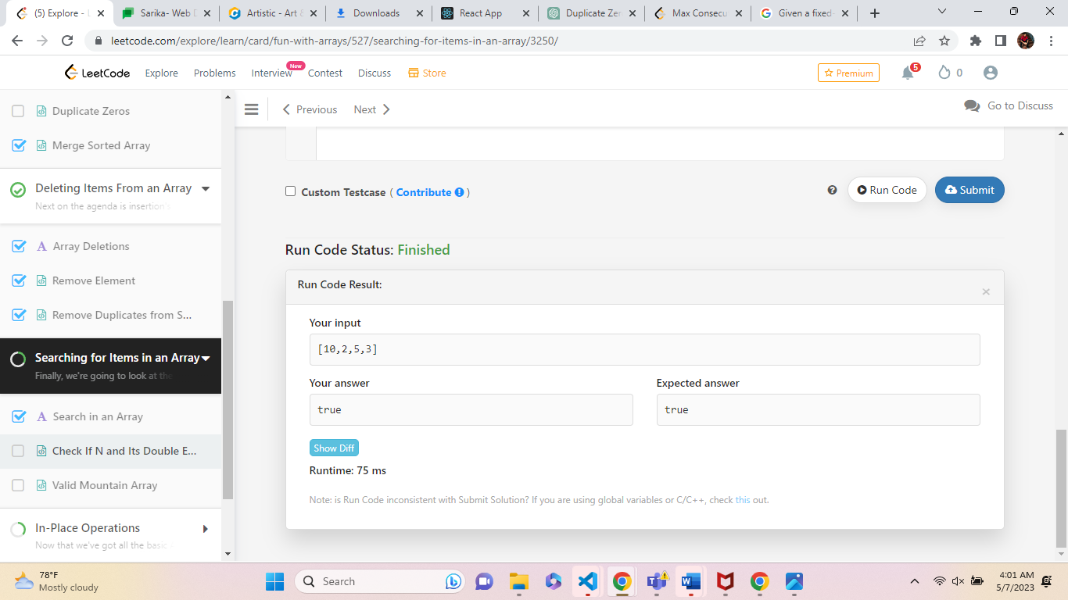

Example 2:

**Input:** arr = [3,1,7,11]

**Output:** false

**Explanation:** There is no i and j that satisfy the conditio

Solution:

var checkIfExist= function(arr){

let result;

for (let i = 0; i < arr.length; i++) {

for (let j = 2; j < arr.length; j++) {

if (arr[i] == 10 == 2 * 5 == 2 * arr[j]) {

return (true);

}

}

return (false)

}

}

Output:

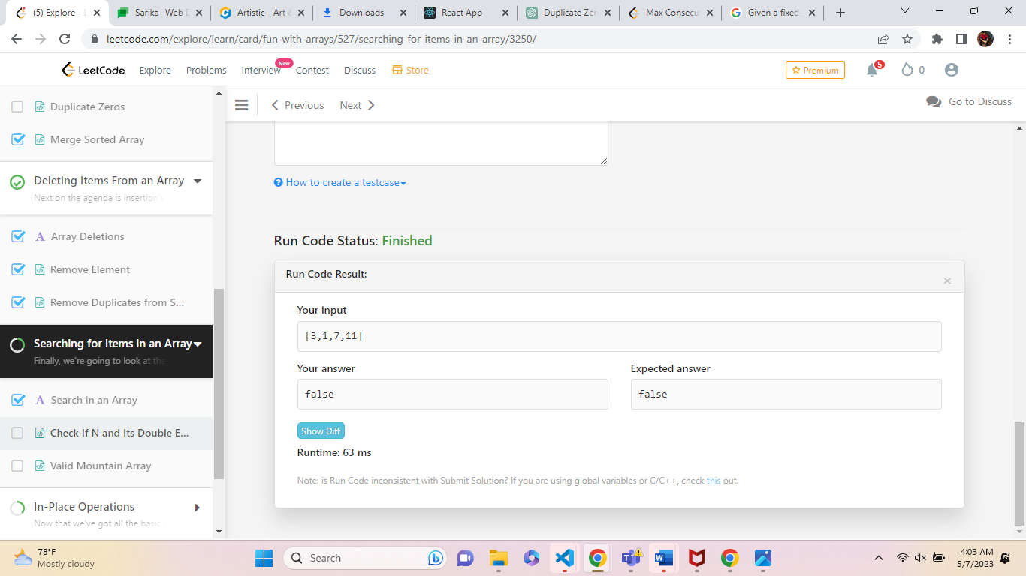

**9. Remove Duplicates from Sorted Array**

Given an integer array nums sorted in **non-decreasing order**, remove the duplicates [**in-place**](https://en.wikipedia.org/wiki/In-place_algorithm) such that each unique element appears only **once**. The **relative order** of the elements should be kept the **same**. Then return the number of unique elements in nums.

**Example 1:**

**Input:** nums = [1,1,2]

**Output:** 2, nums = [1,2,_]

**Explanation:** Your function should return k = 2, with the first two elements of nums being 1 and 2 respectively.

It does not matter what you leave beyond the returned k (hence they are underscores).

Solution:

var removeDuplicates = function(nums) {

let k = 0;

for (let i = 0; i < nums.length; i++) {

if (i == 0 || nums[i] != nums[i - 1]) {

nums[k] = nums[i];

k++;

}

}

return k;

};

Solution:



**Example 2:**

**Input:** nums = [0,0,1,1,1,2,2,3,3,4]

**Output:** 5, nums = [0,1,2,3,4,_,_,_,_,_]

**Explanation:** Your function should return k = 5, with the first five elements of nums being 0, 1, 2, 3, and 4 respectively.

It does not matter what you leave beyond the returned k (hence they are underscores).

Solution:

var removeDuplicates = function(nums) {

let k = 0;

for (let i = 0; i < nums.length; i++) {

if (i == 0 || nums[i] != nums[i - 1]) {

nums[k] = nums[i];

k++;

}

}

return k;

};

Output:

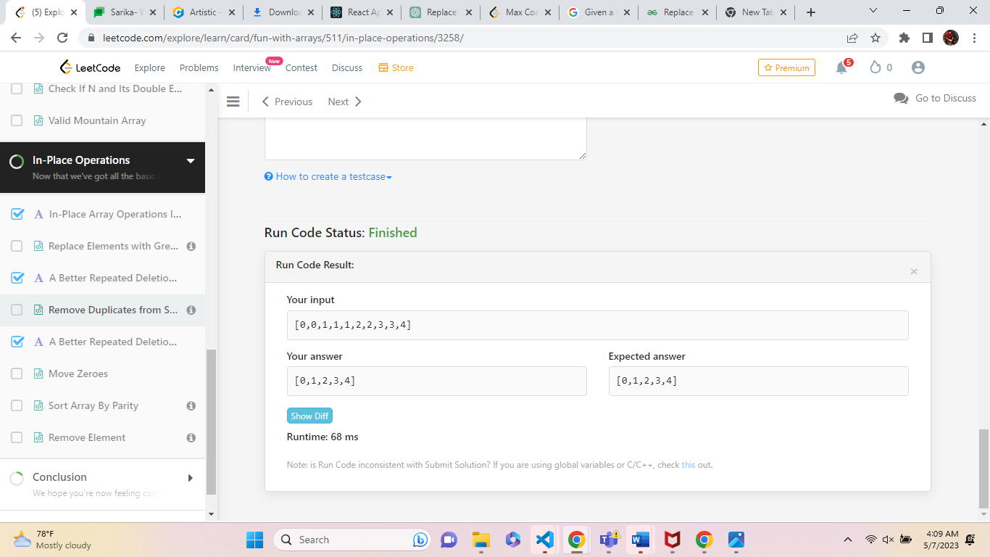

**10. Move Zeroes**

**Solution**

Given an integer array nums, move all 0's to the end of it while maintaining the relative order of the non-zero elements.

**Note** that you must do this in-place without making a copy of the array.

**Example 1:**

**Input:** nums = [0,1,0,3,12]

**Output:** [1,3,12,0,0]

Solution:

function moveZeroes() {

const nums = [0,1,0,3,12];

let i = 0;

for (let j = 0; j < nums.length; j++) {

if (nums[j] !== 0) {

nums[i] = nums[j]; // move the non-zero element to the beginning of the array

i++;

}

}

// fill the rest of the array with zeros

while (i < nums.length) {

nums[i] = 0;

i++;

}

}

Output:

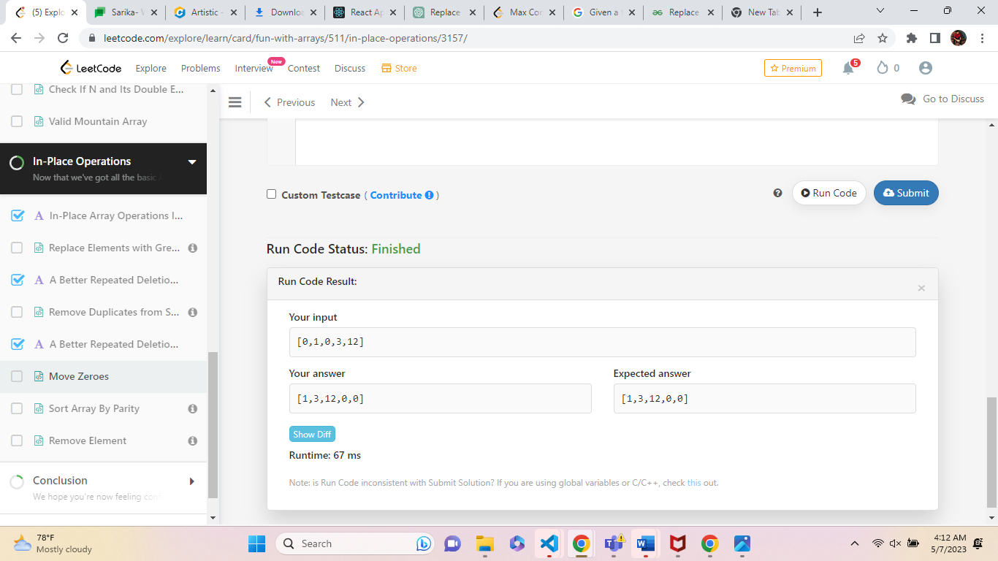

**Example 2:**

**Input:** nums = [0]

**Output:** [0]

function moveZeroes(nums) {

let i = 0;

for (let j = 0; j < nums.length; j++) {

if (nums[j] !== 0) {

nums[i] = nums[j]; // move the non-zero element to the beginning of the array

i++;

}

}

// fill the rest of the array with zeros

while (i < nums.length) {

nums[i] = 0;

i++;

}

}

Output:

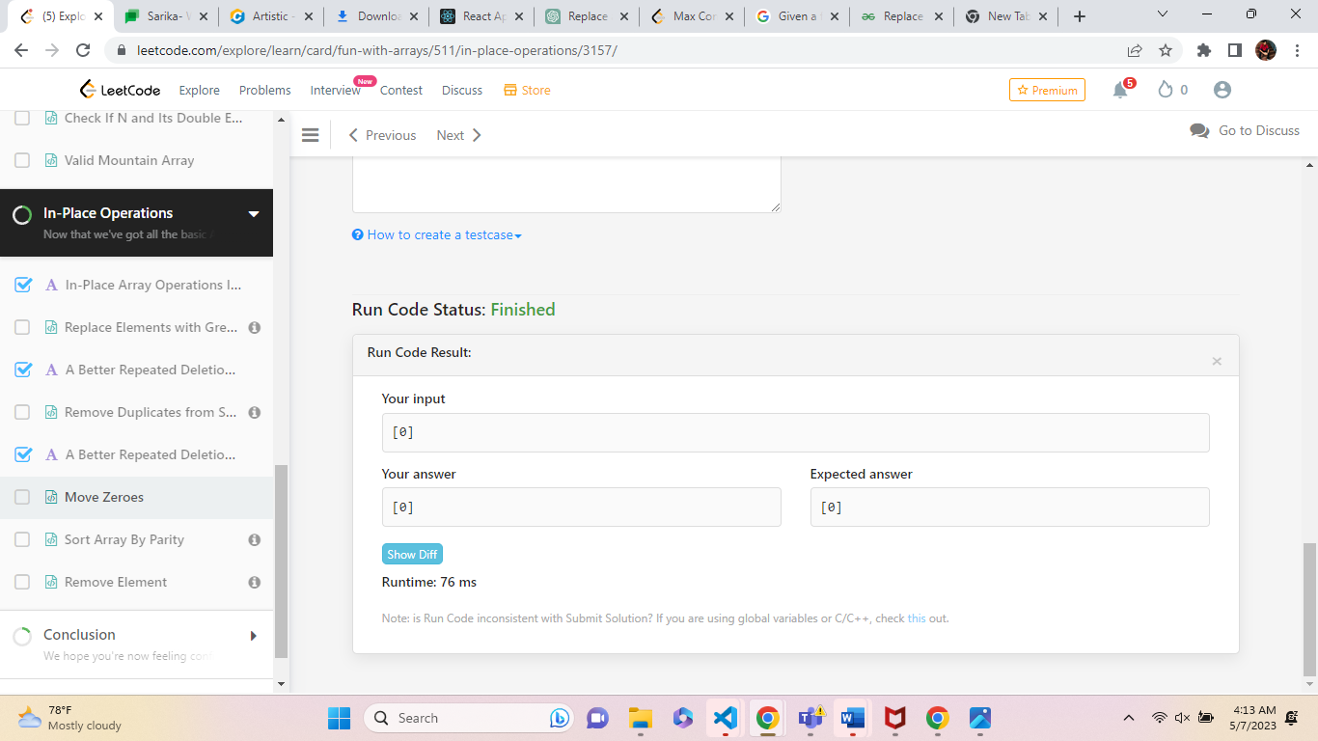

**11. Sort Array By Parity**

**Solution**

Given an integer array nums, move all the even integers at the beginning of the array followed by all the odd integers.

Return ***any array****that satisfies this condition*.

**Example 1:**

**Input:** nums = [3,1,2,4]

**Output:** [2,4,3,1]

**Explanation:** The outputs [4,2,3,1], [2,4,1,3], and [4,2,1,3] would also be accepted.

Solution:

**12.Remove Element**

**Solution**

Given an integer array nums and an integer val, remove all occurrences of val in nums [**in-place**](https://en.wikipedia.org/wiki/In-place_algorithm). The order of the elements may be changed. Then return *the number of elements in*nums*which are not equal to*val

**Example 1:**

**Input:** nums = [3,2,2,3], val = 3

**Output:** 2, nums = [2,2,_,_]

**Explanation:** Your function should return k = 2, with the first two elements of nums being 2.

It does not matter what you leave beyond the returned k (hence they are underscores).

Solution:

function removeElement(nums, val) {

let k = 0;

for (let i = 0; i < nums.length; i++) {

if (nums[i] !== val) {

nums[k] = nums[i];

k++;

}

}

return k;

}

Output:

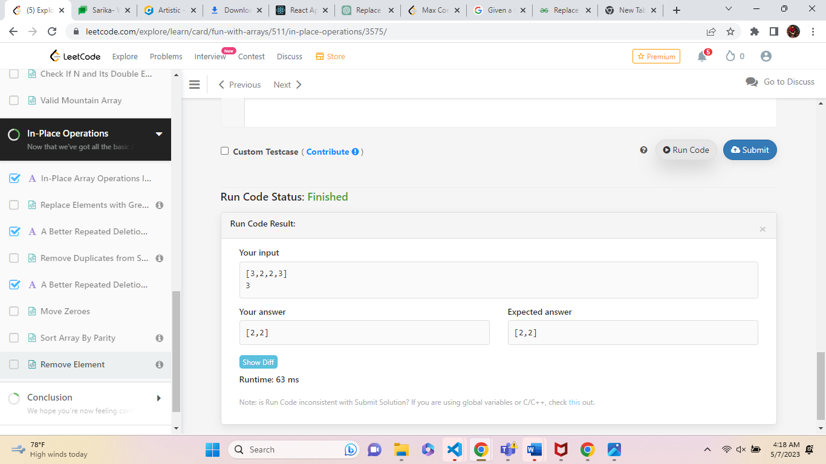

**Example 2:**

**Input:** nums = [0,1,2,2,3,0,4,2], val = 2

**Output:** 5, nums = [0,1,4,0,3,_,_,_]

**Explanation:** Your function should return k = 5, with the first five elements of nums containing 0, 0, 1, 3, and 4.

Note that the five elements can be returned in any order.

It does not matter what you leave beyond the returned k (hence they are underscores).

Solution:

function removeElement(nums, val) {

let k = 0;

for (let i = 0; i < nums.length; i++) {

if (nums[i] !== val) {

nums[k] = nums[i];

k++;

}

}

return k;

}

Ou

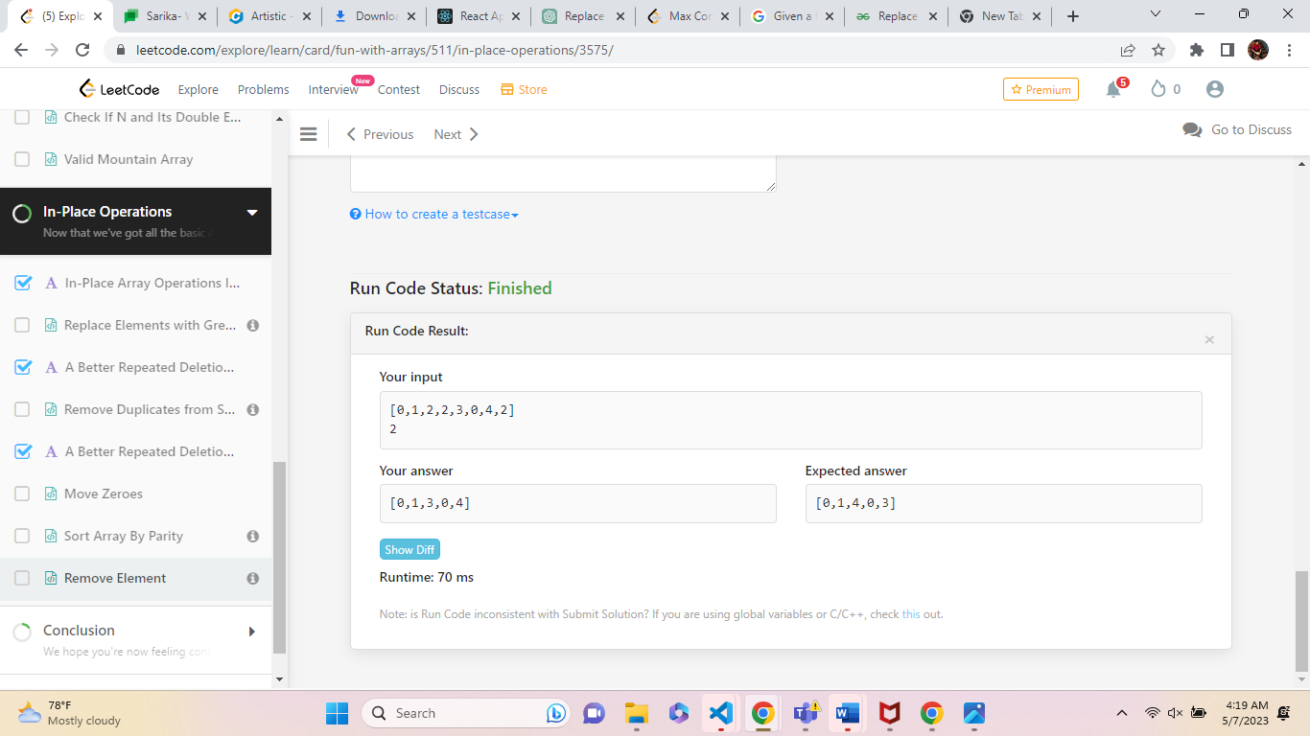

**Squares of a Sorted Array**

**Solution**

Given an integer array nums sorted in **non-decreasing** order, return *an array of****the squares of each number****sorted in non-decreasing order*.

**Example 1:**

**Input:** nums = [-4,-1,0,3,10]

**Output:** [0,1,9,16,100]

**Explanation:** After squaring, the array becomes [16,1,0,9,100].

After sorting, it becomes [0,1,9,16,100].

Solution:

function sortedSquares(nums) {

let result=[]

let start = 0

let end = nums.length-1;

let position = end

while (start <= end) {

if (nums[start] ** 2 > nums[end] ** 2) {

result[position--] = nums[start++]

} else

{

result[position--] = nums[end--] ** 2

}

}

return result;

};

Output:

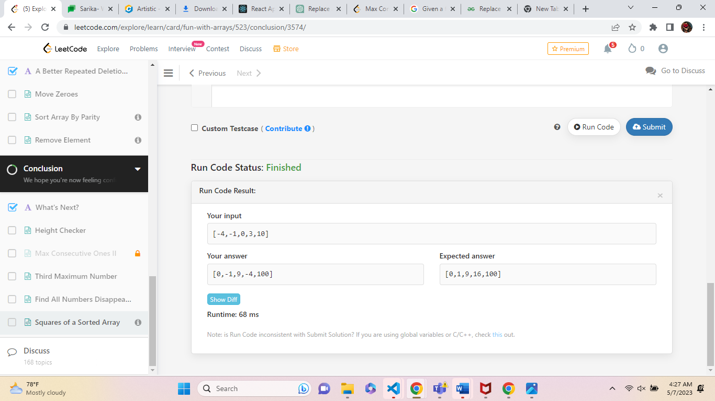

**14.Third Maximum Number**

**Solution**

Given an integer array nums, return *the****third distinct maximum****number in this array. If the third maximum does not exist, return the****maximum****number*.

**Example 1:**

**Input:** nums = [3,2,1]

**Output:** 1

**Explanation:**

The first distinct maximum is 3.

The second distinct maximum is 2.

The third distinct maximum is 1.

Solution:

var thirdMax = function(nums) {

let firstMax = -Infinity

let secondMax = -Infinity

let thirdMax = -Infinity

let n =nums;

if(n == firstMax || n == secondMax || nu == thirdMax)

if(firstMax < n){

thirdMax = secondMax

secondMax = firstMax

firstMax = n

}else if(secondMax < n){

thirdMax = secondMax

secondMax = nums

}else if(thirdMax < n){

thirdMax = n

}

}

if(thirdMax === -Infinity){

return firstMax

}else{

return thirdMax

}

Output:

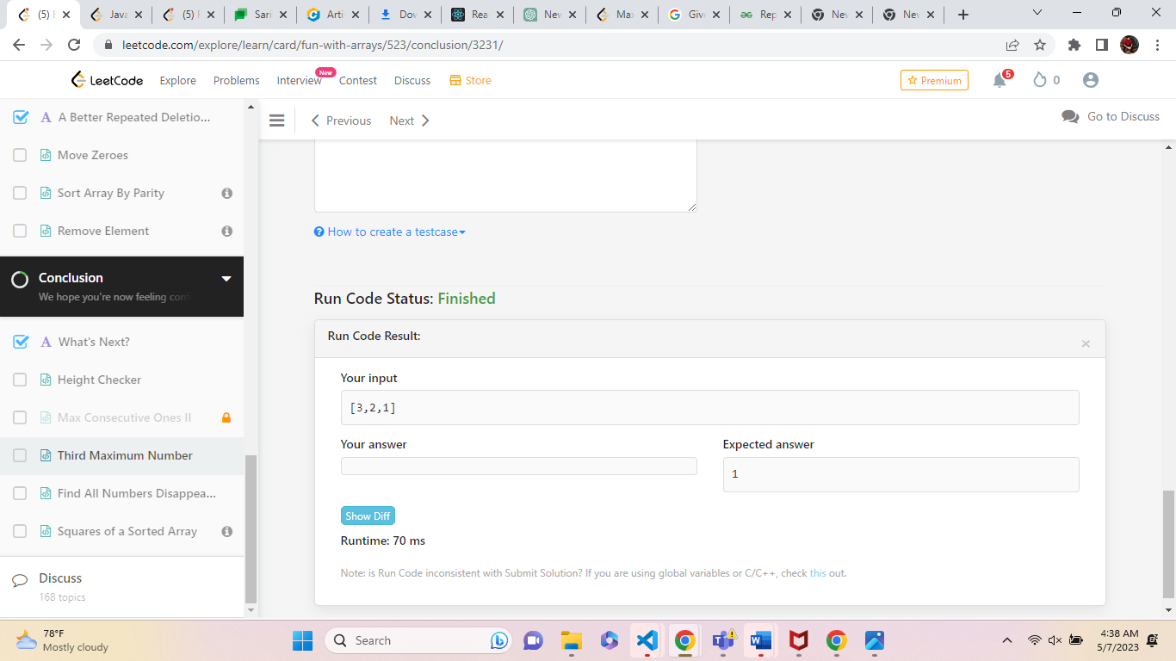

15.

**Height Checker**

A school is trying to take an annual photo of all the students. The students are asked to stand in a single file line in **non-decreasing order** by height. Let this ordering be represented by the integer array expected where expected[i] is the expected height of the ith student in line.

**Example 1:**

**Input:** heights = [1,1,4,2,1,3]

**Output:** 3

**Explanation:**

heights: [1,1,4,2,1,3]

expected: [1,1,1,2,3,4]

Indices 2, 4, and 5 do not match.

function heightChecker() {

const heights= [1,1,4,2,1,3];

const expected= [1,1,1,2,3,4];

let number = 0;

for (let i = 0; i < heights.length; i++) {

if (heights[i] !== expected[i]) {

number++;

}

}

return number;

}

Output:

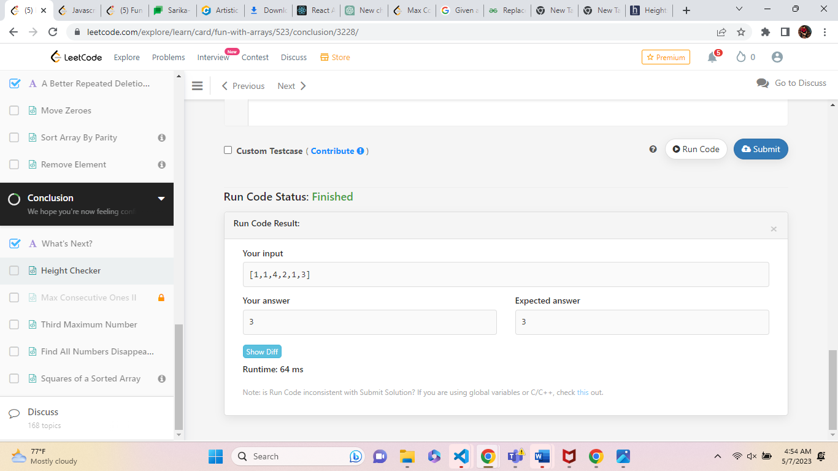

Write a program to reverse a given string [0, 1, 2, 3, 4]?

function Myfun(){

    let result=[]

   const array=[]

const arr = [1, 2, 3, 4];

for (let i = arr.length - 1; i >= 0; i--) {

    array.push(arr[i]);

}

    result.push(array)

    console.log("arrayvalue", array)

      return (

        <div>

              <lable>Element in i & j is:</lable>

              {result.map(array => {

                  return (

                      <div>

                          {array.map((ele) => {

                              //  console.log('ele', ele);

                              return (

                                  <div>

                                      {ele}

                                  </div>

                              );

                          })}

                      </div>

                  );

              })}

          </div>

      );

      }

      export default Myfun;

Output:

